Todays Agenda : 15-04-2024

|  |
| --- |
| **Java Object-Oriented Programming (OOP) Basics** |
| Object-Oriented Programming (OOP) |
| Classes and Objects: Definitions and Differences |
| Constructors: Purpose and Types |
| Encapsulation: Access Modifiers and Getters/Setters |
| Inheritance: Superclass and Subclass Relationships |
| Polymorphism: Method Overloading and Overriding |
| Organizing Code |
| Packages: Creating and Using Packages |
| Classpath: Understanding and Setting the Classpath |
| Java Modules: Modular Programming in Java |

OOPs (Object-Oriented Programming System)

**Object** means a real-world entity such as a pen, chair, table, computer, watch, etc. **Object-Oriented Programming** is a methodology or paradigm to design a program using classes and objects. It simplifies software development and maintenance by providing some concepts:

* [Object](https://www.javatpoint.com/object-and-class-in-java)
* Class
* [Inheritance](https://www.javatpoint.com/inheritance-in-java)
* [Polymorphism](https://www.javatpoint.com/runtime-polymorphism-in-java)
* [Abstraction](https://www.javatpoint.com/abstract-class-in-java)
* [Encapsulation](https://www.javatpoint.com/encapsulation)

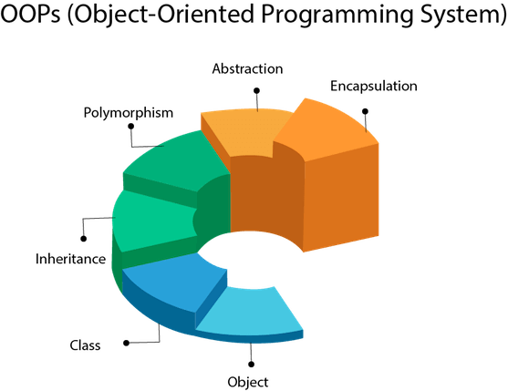

Constructors: Purpose and Types

A constructor in Java is a special type of method that is used to initialize an object. It is called when an instance of an object is created and memory is allocated for the object.

The purpose of a constructor is to initialize the object's state. This can be done by assigning values to the object's fields, or by performing other tasks such as creating other objects or opening files.

**There are three types of constructors in Java:**

* Default constructor:

This constructor does not take any arguments. It is the simplest type of constructor, and it is provided by the Java compiler if you do not define any other constructors.

* Parameterized constructor:

This constructor takes one or more arguments. The arguments are used to initialize the object's fields.

Here is an example of a class with a default constructor:

public class Person {  
 private String name;  
  
 public Person() {  
 this.name = "John Doe";  
 }  
}

Here is an example of a class with a parameterized constructor:

public class Person {  
 private String name;  
 private int age;  
  
 public Person(String name1, int age1) {  
 this.name = name1;  
 this.age = age1;  
 }  
}

**Polymorphism**

Polymorphism is the ability of an object to take on many forms. The most common use of polymorphism in OOP occurs when a parent class reference is used to refer to a child class object.

Any Java object that can pass more than one IS-A test is considered to be polymorphic. In Java, all Java objects are polymorphic since any object will pass the IS-A test for their own type and for the class Object.

It is important to know that the only possible way to access an object is through a reference variable. A reference variable can be of only one type. Once declared, the type of a reference variable cannot be changed.

The reference variable can be reassigned to other objects provided that it is not declared final. The type of the reference variable would determine the methods that it can invoke on the object.

A reference variable can refer to any object of its declared type or any subtype of its declared type. A reference variable can be declared as a class or interface type.

### **Example**

Let us look at an example.

public interface Vegetarian{}

public class Animal{}

public class Deer extends Animal implements Vegetarian{}

Now, the Deer class is considered to be polymorphic since this has multiple inheritance. Following are true for the above examples −

* A Deer IS-A Animal
* A Deer IS-A Vegetarian
* A Deer IS-A Deer
* A Deer IS-A Object

When we apply the reference variable facts to a Deer object reference, the following declarations are legal −

### **Example**

Deer d = new Deer();

Animal a = d;

Vegetarian v = d;

Object o = d;

All the reference variables d, a, v, o refer to the same Deer object in the heap.

In other words, polymorphism allows you to define one interface and have multiple implementations. The word “poly” means many and “morphs” means forms, So it means many forms.

**Types of polymorphism**

In Java polymorphism is mainly divided into two types:

* Compile-time Polymorphism
* Runtime Polymorphism

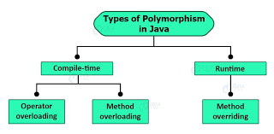

**Type 1:**Compile-time polymorphism

Compile time is also known as static polymorphism. This type of polymorphism is achieved by function overloading.

*method(int o, int a);// arg:2 method(1,2);*

*method(int o);//arg 1*

*method(int a, int b, int c);//3*

*method(int a, String b);//2 //compile error// method(1,”Train”)*

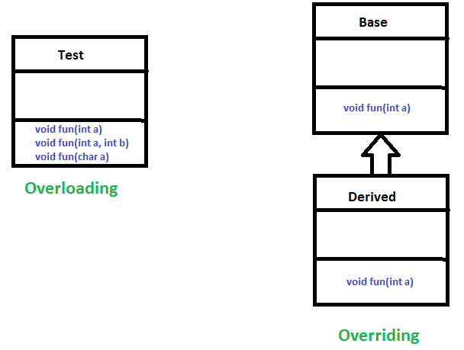

**Method Overloading**: When there are multiple functions with the same name but different parameters then these functions are said to be **overloaded**. Functions can be overloaded by change in the number of arguments or/and a change in the type of arguments.

**Example 1**

IDE1, IDE2

**Type 2:**[Runtime polymorphism](https://www.geeksforgeeks.org/dynamic-method-dispatch-runtime-polymorphism-java/)

It is also known as Dynamic Method Dispatch. It is a process in which a function call to the overridden method is resolved at Runtime. This type of polymorphism is achieved by Method Overriding. [**Method overriding**](https://www.geeksforgeeks.org/overriding-in-java/), on the other hand, occurs when a derived class has a definition for one of the member functions of the base class. That base function is said to be **overridden**.

**Example**

IDE

****************************************END*****************************************

**Encapsulation in Java**

Encapsulation is defined as the wrapping up of data under a single unit. It is the mechanism that binds together code and the data it manipulates. Another way to think about encapsulation is, it is a protective shield that prevents the data from being accessed by the code outside this shield. 

* Technically in encapsulation, the variables or data of a class is hidden from any other class and can be accessed only through any member function of its own class in which it is declared.
* As in encapsulation, the data in a class is hidden from other classes using the data hiding concept which is achieved by making the members or methods of a class private, and the class is exposed to the end-user or the world without providing any details behind implementation using the abstraction concept, so it is also known as a **combination of data-hiding and abstraction**.
* Encapsulation can be achieved by Declaring all the variables in the class as private and writing public methods in the class to set and get the values of variables
* It is more defined with setter and getter method.

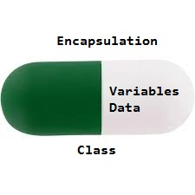

The get methods like getAge() , getName() , getRoll() are set as public, these methods are used to access these variables. The setter methods like setName(), setAge(), setRoll() are also declared as public and are used to set the values of the variables.

**Advantages of Encapsulation**:

* **Data Hiding:** The user will have no idea about the inner implementation of the class. It will not be visible to the user how the class is storing values in the variables. The user will only know that we are passing the values to a setter method and variables are getting initialized with that value.
* **Increased Flexibility:** We can make the variables of the class read-only or write-only depending on our requirement. If we wish to make the variables read-only then we have to omit the setter methods like setName(), setAge(), etc. from the above program or if we wish to make the variables as write-only then we have to omit the get methods like getName(), getAge(), etc. from the above program
* **Reusability:** Encapsulation also improves the re-usability and is easy to change with new requirements.
* **Testing code is easy:** Encapsulated code is easy to test for unit testing.// Framework:Mockito,JUNIT Approaches: TDD,BDD

*****************************END************************************** Mockito**

# Interfaces in Java

 An interface in Java is a blueprint of a class. A Java interface contains static constants and abstract methods.

The interface in Java is *a*mechanism to achieve [abstraction](https://www.geeksforgeeks.org/abstraction-in-java-2/). There can be only abstract methods in the Java interface, not the method body.

It is used to achieve abstraction and [multiple inheritance in Java](https://www.geeksforgeeks.org/java-and-multiple-inheritance/). In other words, you can say that interfaces can have abstract methods and variables. It cannot have a method body. Java Interface also **represents the IS-A relationship**

Like a class, an interface can have methods and variables, but the methods declared in an interface are by default abstract (only method signature, no body).

* Interfaces specify what a class must do and not how. It is the blueprint of the class.
* An Interface is about capabilities like a Player may be an interface and any class implementing Player must be able to (or must implement) move(). So it specifies a set of methods that the class has to implement.
* If a class implements an interface and does not provide method bodies for all functions specified in the interface, then the class must be declared abstract.
* A Java library example is [Comparator Interface](https://www.geeksforgeeks.org/comparator-interface-java/). If a class implements this interface, then it can be used to sort a collection.

**Syntax:**

Interface {

// declare constant fields

// declare methods that abstract

// by default.

}

# Abstract class in Java

A class which is declared with the abstract keyword is known as an abstract class in [Java](https://www.javatpoint.com/java-tutorial). It can have abstract and non-abstract methods (method with the body).

Before learning the Java abstract class, let's understand the abstraction in Java first.

### **Abstraction in Java**

**Abstraction** is a process of hiding the implementation details and showing only functionality to the user.

Another way, it shows only essential things to the user and hides the internal details, for example, sending SMS where you type the text and send the message. You don't know the internal processing about the message delivery.

Abstraction lets you focus on what the [object](https://www.javatpoint.com/object-and-class-in-java) does instead of how it does it.

### **Ways to achieve Abstraction**

There are two ways to achieve abstraction in java

1. Abstract class (0 to 100%)
2. Interface (100%)

### **Abstract class in Java**

A class which is declared as abstract is known as an **abstract class**. It can have abstract and non-abstract methods. It needs to be extended and its method implemented. It cannot be instantiated.

#### **Points to Remember**

* An abstract class must be declared with an abstract keyword.
* It can have abstract and non-abstract methods.
* It cannot be instantiated.
* It can have [constructors](https://www.javatpoint.com/java-constructor) and static methods also.
* It can have final methods which will force the subclass not to change the body of the method.

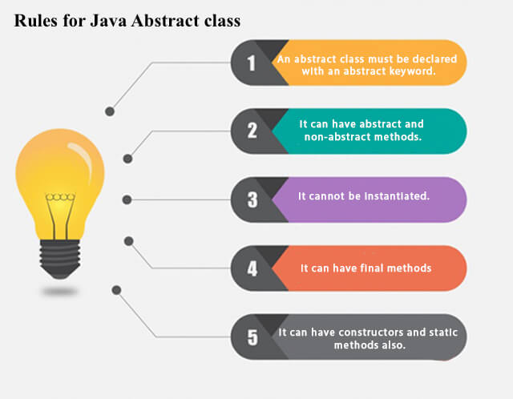

**Example of abstract class**

**abstract** **class** A{}

### **Abstract Method in Java**

A method which is declared as abstract and does not have implementation is known as an abstract method.

**Example of abstract method**

1. **abstract** **void** printStatus();//no method body and abstract

### **Understanding the real scenario of Abstract class**

In this example, Shape is the abstract class, and its implementation is provided by the Rectangle and Circle classes.

Mostly, we don't know about the implementation class (which is hidden to the end user), and an object of the implementation class is provided by the **factory method**.

A **factory method** is a method that returns the instance of the class. We will learn about the factory method later.

In this example, if you create the instance of Rectangle class, draw() method of Rectangle class will be invoked.

**abstract** **class** Shape{

**abstract** **void** draw();

}

//In real scenario, implementation is provided by others i.e. unknown by end user

**class** Rectangle **extends** Shape{

**void** draw(){System.out.println("drawing rectangle");}

}

**class** Circle1 **extends** Shape{

**void** draw(){System.out.println("drawing circle");}

}

**class** TestAbstraction1{

**public** **static** **void** main(String args[]){

Shape s=**new** Circle1();//In a real scenario, object is provided through method, e.g., getShape() method

s.draw();

}

}

drawing circle

## **Types of inheritance in java**

On the basis of class, there can be three types of inheritance in java: single, multilevel and hierarchical.

In java programming, multiple and hybrid inheritance is supported through interface only. We will learn about interfaces later.

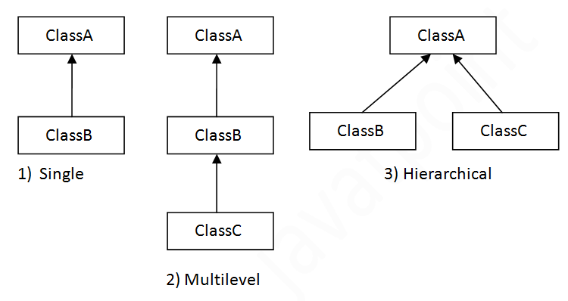

#### **Note: Multiple inheritance is not supported in Java through class.**

When one class inherits multiple classes, it is known as multiple inheritance. For Example:

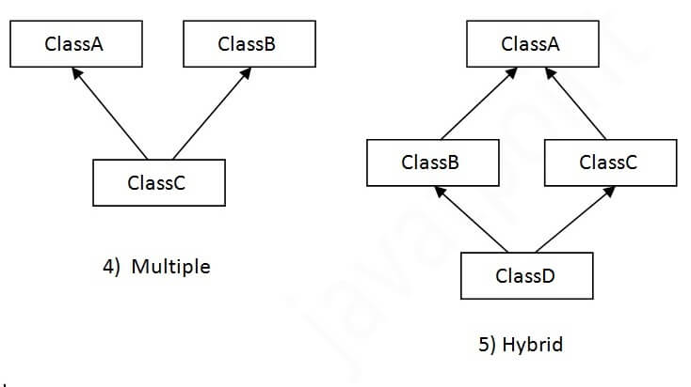

## **Single Inheritance Example**

When a class inherits another class, it is known as a single inheritance. In the example given below, Dog class inherits the Animal class, so there is the single inheritance.

**class** Animal{

**void** eat(){System.out.println("eating...");}

}

**class** Dog **extends** Animal{

**void** bark(){System.out.println("barking...");}

}

**class** TestInheritance{

**public** **static** **void** main(String args[]){

Dog d=**new** Dog();

d.bark();  //function calling

d.eat();

}}

Output:

barking...

eating...

## **Multilevel Inheritance Example**

When there is a chain of inheritance, it is known as multilevel inheritance. As you can see in the example given below, BabyDog class inherits the Dog class which again inherits the Animal class, so there is a multilevel inheritance.

**class** Animal{

**void** eat(){System.out.println("eating...");}

}

**class** Dog **extends** Animal{

**void** bark(){System.out.println("barking...");}

}

**class** BabyDog **extends** Dog{

**void** weep(){System.out.println("weeping...");}

}

**class** TestInheritance2{

**public** **static** **void** main(String args[]){

BabyDog d=**new** BabyDog();

d.weep();

d.bark();

d.eat();

}}

Output:

weeping...

barking...

eating...

## **Hierarchical Inheritance Example**

When two or more classes inherits a single class, it is known as hierarchical inheritance. In the example given below, Dog and Cat classes inherits the Animal class, so there is hierarchical inheritance.

**class** Animal{

**void** eat(){System.out.println("eating...");}

}

**class** Dog **extends** Animal{

**void** bark(){System.out.println("barking...");}

}

**class** Cat **extends** Animal{

**void** meow(){System.out.println("meowing...");}

}

**class** TestInheritance3{

**public** **static** **void** main(String args[]){

Cat c=**new** Cat();

c.meow();

c.eat();

//c.bark();//C.T.Error

}}

Output:

meowing...

eating...

## **Q) Why multiple inheritance is not supported in java?**

To reduce the complexity and simplify the language, multiple inheritance is not supported in java.

Consider a scenario where A, B, and C are three classes. The C class inherits A and B classes. If A and B classes have the same method and you call it from child class object, there will be ambiguity to call the method of A or B class.

Since compile-time errors are better than runtime errors, Java renders compile-time error if you inherit 2 classes. So whether you have same method or different, there will be compile time error.

Java Package

A **java package** is a group of similar types of classes, interfaces and sub-packages.

Package in java can be categorized in two form, built-in package and user-defined package.

There are many built-in packages such as java, lang, awt, javax, swing, net, io, util, sql etc.

Here, we will have the detailed learning of creating and using user-defined packages.

## **Advantage of Java Package**

1) Java package is used to categorize the classes and interfaces so that they can be easily maintained.

2) Java package provides access protection.

3) Java package removes naming collision.

Import java.util.Scanner;

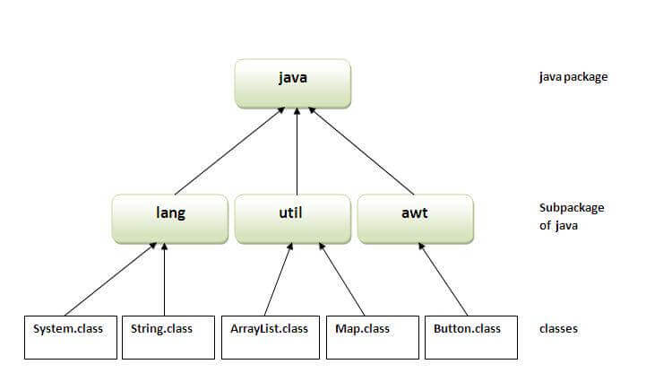

## **Simple example of java package**

The **package keyword** is used to create a package in java.

1. //save as Simple.java
2. **package** mypack;
3. **public** **class** Simple{
4. **public** **static** **void** main(String args[]){
5. System.out.println("Welcome to package");
6. }
7. }

## **How to compile java package**

If you are not using any IDE, you need to follow the **syntax** given below:

1. javac -d directory javafilename

For **example**

1. javac -d . Simple.java

The -d switch specifies the destination where to put the generated class file. You can use any directory name like /home (in case of Linux), d:/abc (in case of windows) etc. If you want to keep the package within the same directory, you can use . (dot).

## **How to run java package program**

You need to use fully qualified name e.g. mypack.Simple etc to run the class.

/Training/src/com/wipro/basics/array/DeleteArray.java

|  |
| --- |
| **To Compile:** javac -d . DeleteArray.java |
| **To Run:** java mypack.Simple |

Output:Welcome to package

|  |
| --- |
| The -d is a switch that tells the compiler where to put the class file i.e. it represents destination. The . represents the current folder. |

## **How to access package from another package?**

There are three ways to access the package from outside the package.

1. import package.*;
2. import package.classname;
3. fully qualified name.

#### **1) Using packagename.\***

If you use package.* then all the classes and interfaces of this package will be accessible but not subpackages.

The import keyword is used to make the classes and interface of another package accessible to the current package.

## **Example of package that import the packagename.\***

1. //save by A.java
2. **package** pack;
3. **public** **class** A{
4. **public** **void** msg(){System.out.println("Hello");}
5. }
6. //save by B.java
7. **package** mypack;
8. **import** pack.*;
10. **class** B{
11. **public** **static** **void** main(String args[]){
12. A obj = **new** A();
13. obj.msg();
14. }
15. }

Output:Hello

#### **2) Using packagename.classname**

If you import package.classname then only declared class of this package will be accessible.

## **Example of package by import package.classname**

1. //save by A.java
3. **package** pack;
4. **public** **class** A{
5. **public** **void** msg(){System.out.println("Hello");}
6. }
7. //save by B.java
8. **package** mypack;
9. **import** pack.A;
11. **class** B{
12. **public** **static** **void** main(String args[]){
13. A obj = **new** A();
14. obj.msg();
15. }
16. }

Output:Hello

#### **3) Using fully qualified name**

If you use fully qualified name then only declared class of this package will be accessible. Now there is no need to import. But you need to use fully qualified name every time when you are accessing the class or interface.

It is generally used when two packages have same class name e.g. java.util and java.sql packages contain Date class.

## **Example of package by import fully qualified name**

1. //save by A.java
2. **package** pack;
3. **public** **class** A{
4. **public** **void** msg(){System.out.println("Hello");}
5. }
6. //save by B.java
7. **package** mypack;
8. **class** B{
9. **public** **static** **void** main(String args[]){
10. pack.A obj = **new** pack.A();//using fully qualified name
11. obj.msg();
12. }
13. }

Output:Hello

#### **Note: Sequence of the program must be package then import then class.**

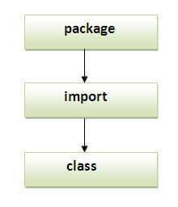

Classpath: Understanding and Setting the Classpath

The classpath is an environment variable in Java that tells the Java compiler and Java Virtual Machine (JVM) where to find the .class files needed to run a Java program. The classpath can be set in a variety of ways, including:

* Using the -classpath command-line option: This option allows you to specify the classpath when you run a Java program. For example, the following command would run the Java program MyProgram.class using the classpath specified by the -classpath option:

java -classpath .:/path/to/my/classes MyProgram

Java Modules: Modular Programming in Java

Modular programming is a software design technique that emphasizes separating the functionality of a program into independent, interchangeable modules, such that each contains everything necessary to execute only one aspect of the desired functionality.

In Java, modular programming is implemented using the module-info.java file. This file contains information about the module, such as its name, dependencies, and exports.

To create a module in Java, you must first create a directory for the module. Then, you must create a module-info.java file in the directory. The module-info.java file must contain the following information:

* The name of the module
* The dependencies of the module
* The exports of the module

The dependencies of a module are the other modules that the module needs in order to function. The exports of a module are the packages that the module makes available to other modules.

For example, the following module-info.java file defines a module named my-module:

module my-module {  
 requires java.base;  
 exports com.example.mymodule;  
}